**Q1. Sort the data set alphabetically by the Product name in column A.**

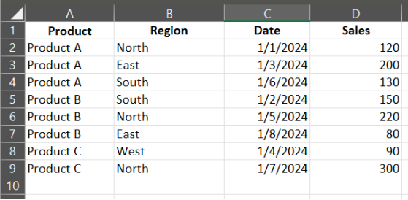

**Q2. Sort the data set by Sales in descending order.**

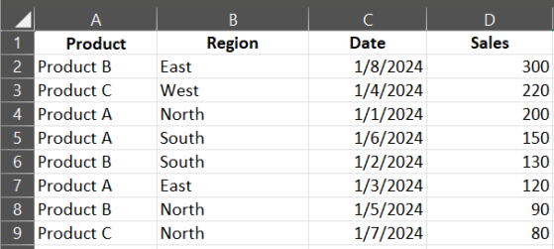

**Q3. Sort the dataset first by Region in alphabetical order, and then by Sales in ascending order within each Region.**

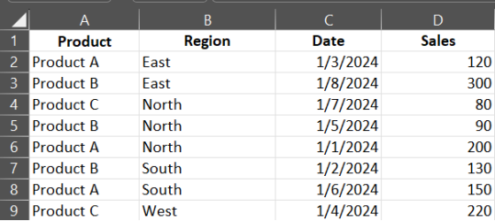

**Q4. Apply a filter to display only the rows where the Product is "Product B".**

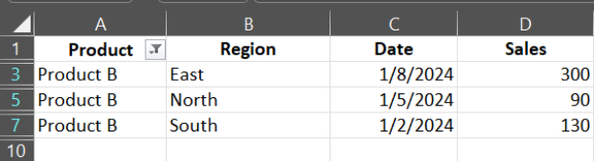

**Q5. Apply a filter to display only the rows where the Sales are greater than 150.**

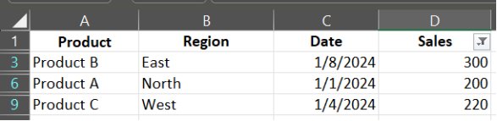

**Q6. Apply a filter to display only the rows where the Date is in January 2024.**

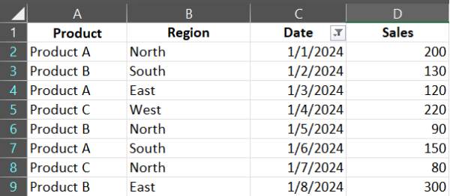

**Q7. Sort the data set first by Date in chronological order, and then by Sales in descending order within each Date.**

